Project 3

Step1:Create two linux instances,Use the first free linux AMI

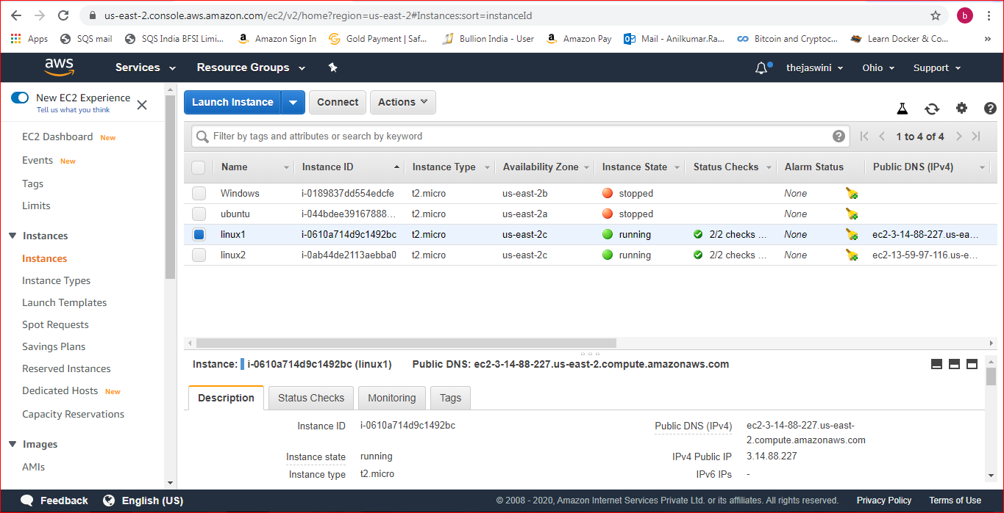

Step2:Launch both instances using Mobaxterm

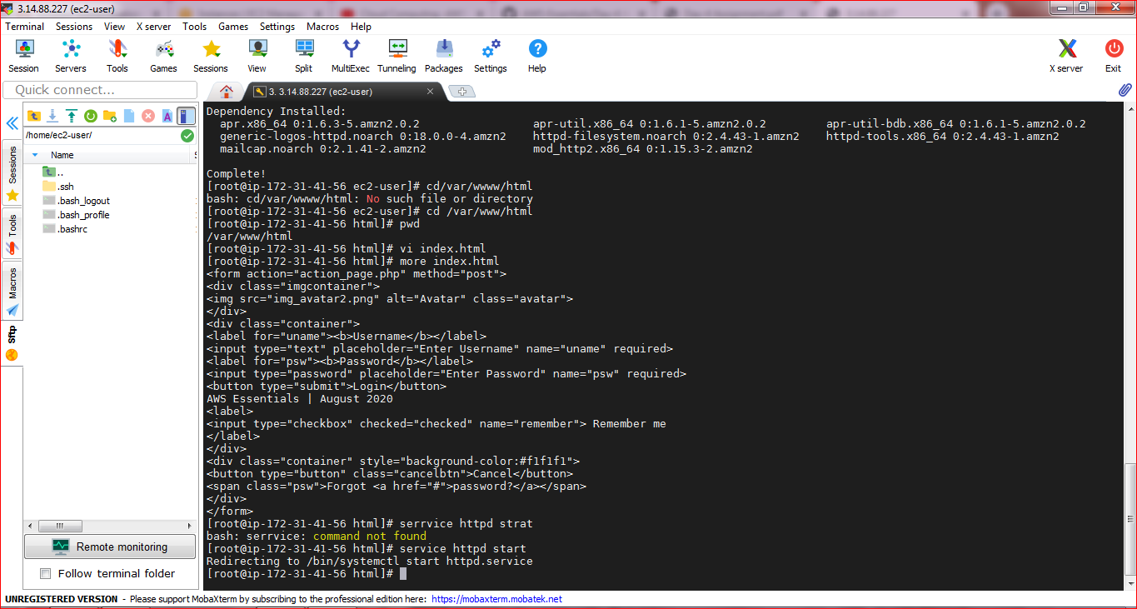

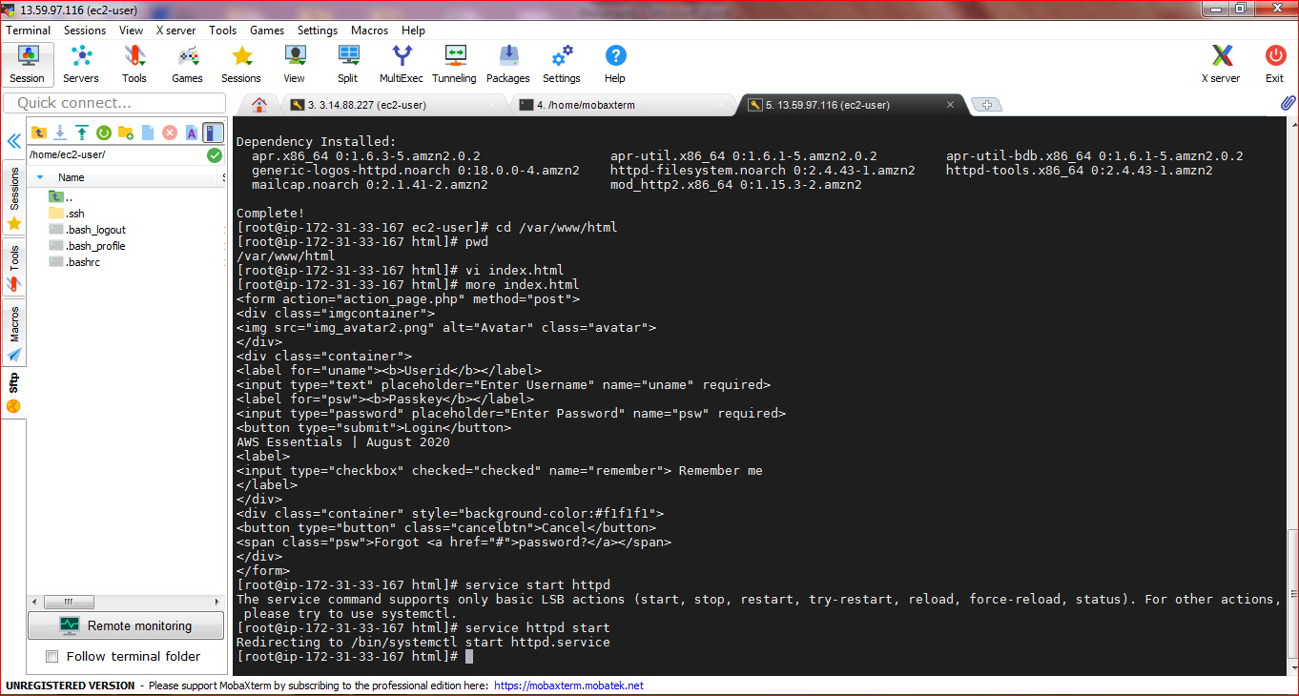

Step5:Check if the application is deployed on both servers by copy pasting the public ip of the servers into the browser.

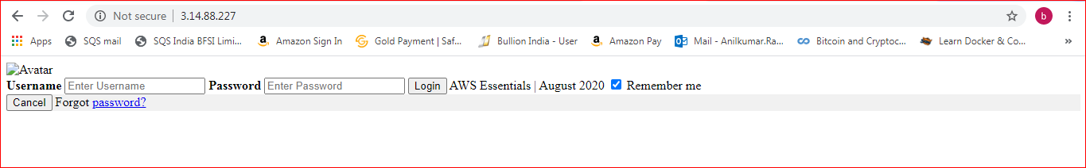

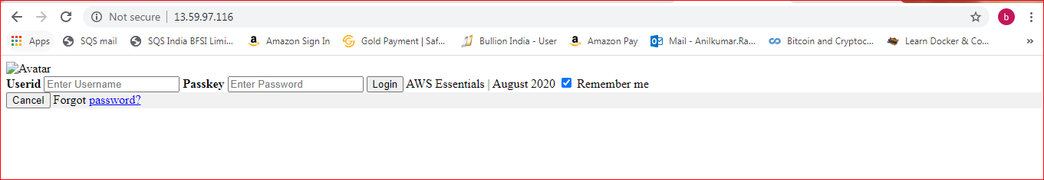

Step6:Create a application Load balancer with the above two instances as targets

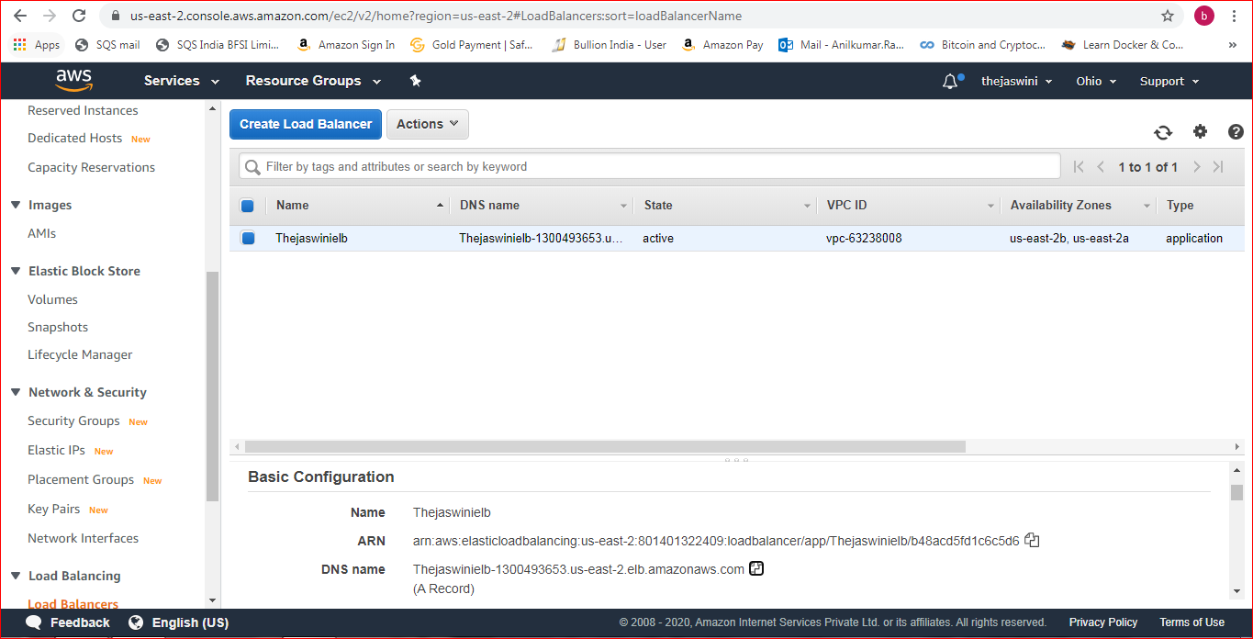  
Step7:Check the functioning of ELB

